Junit Basic Testing
1.Setting Up Junit
SimpleTest.java
import org.junit.jupiter.api.Test;
import static org.junit.jupiter.api.Assertions.assertEquals;
public class SimpleTest {
@Test
public void testAddition() {
int result = 2 + 3;
assertEquals(5, result);
}
}
Junit Dependency
<dependencies>
<dependency>
<groupId>junit</groupId>
<artifactId>junit </artifactId>
<version>4.13.2</version>
<scope>test</scope>
</dependency>
</dependencies>
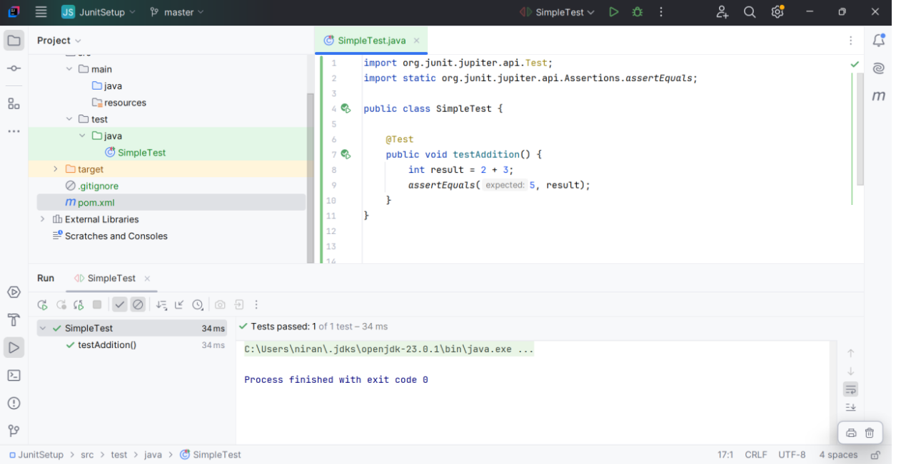

2.Writing Basic Junit Tests
Calculator.java
public class Calculator {
public int add(int a, int b) {
return a + b;
}
public int subtract(int a, int b) {
return a - b;
}

public int multiply(int a, int b) {
return a * b;
}

public int divide(int a, int b) {
if (b == 0) {
throw new IllegalArgumentException("Cannot divide by zero!");
}
return a / b;
}
}
CalculatorTest.java
import org.junit.jupiter.api.Test;
import static org.junit.jupiter.api.Assertions.*;

public class CalculatorTest {

Calculator calc = new Calculator();

@Test
void testAdd() {
assertEquals(5, calc.add(2, 3));
}

@Test
void testSubtract() {
assertEquals(1, calc.subtract(4, 3));
}

@Test
void testMultiply() {
assertEquals(6, calc.multiply(2, 3));
}

@Test
void testDivide() {
assertEquals(2, calc.divide(6, 3));
}

@Test
void testDivideByZero() {

Exception exception = assertThrows(IllegalArgumentException.class, () ->
{
calc.divide(5, 0);
});
assertEquals("Cannot divide by zero!", exception.getMessage());
}
}
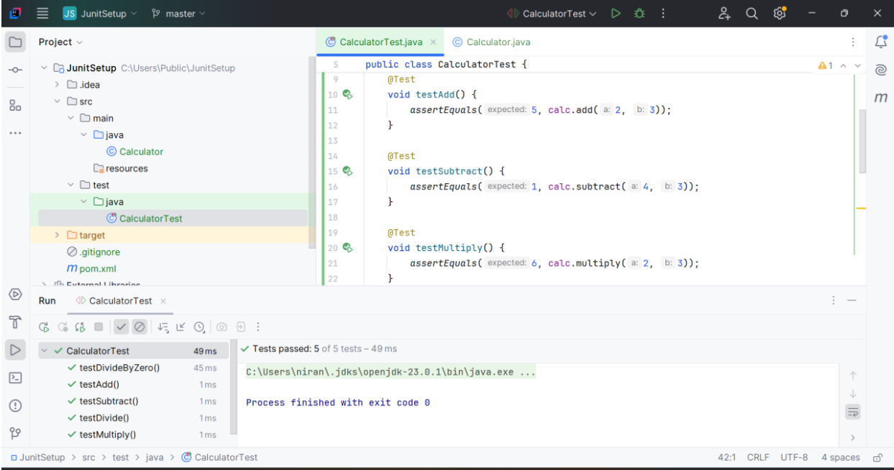

3. Assertions in Junit
AssertionsTest.java
import org.junit.jupiter.api.Test;
import static org.junit.jupiter.api.Assertions.*;

public class AssertionsTest {

@Test
public void testAssertions() {
assertEquals(5, 2 + 3);
assertTrue(5 > 3);
assertFalse(5 < 3);

Object obj1 = null;
assertNull(obj1);

Object obj2 = new Object();
assertNotNull(obj2);
}
}

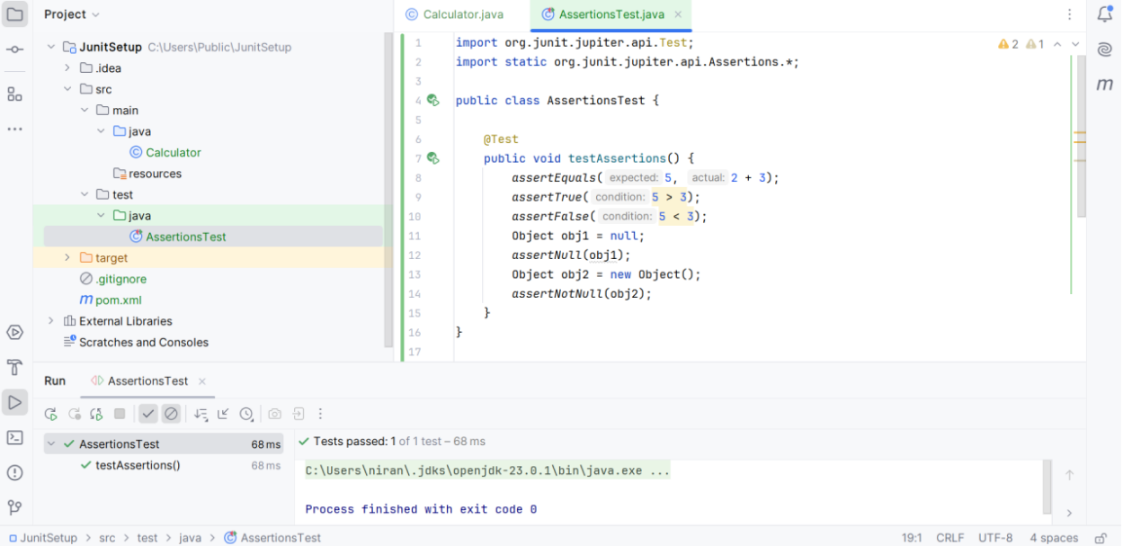

4. Arrange-Act-Assert Pattern in JUnit
CalculatorAAATest.java
import org.junit.jupiter.api.*;
import static org.junit.jupiter.api.Assertions.assertEquals;

public class CalculatorAAATest {
private Calculator calculator;

@BeforeEach
void setUp() {
System.out.println("Setting up Calculator...");
calculator = new Calculator();
}

@AfterEach
void tearDown() {
System.out.println("Tearing down...");
calculator = null;
}

@Test
void testAddition() {
int result = calculator.add(10, 5);
assertEquals(15, result);
}

@Test
void testSubtraction() {
int result = calculator.subtract(10, 4);
assertEquals(6, result);
}
}
